**SmokeTrace DiagnosticTool**

**User Guide**

**2014-03-06 (Revision 02)**

# General

## 1.1 Purpose

SmokeTrace Diagnostic tool is designed for demonstrating the suitability of SmokeTrace algorithm without technical knowledge of the ADPRO® FastTrace and associated hardware system. This tool can also aid the design to determine the best camera angles, Field of View (FOV) and camera placement for SmokeTrace.

**Note:**

1. Although SmokeTrace Diagnostic tool uses the identical SmokeTrace algorithm on the FastTrace systems, it might not perform exact the same in term of detection performance and speed due to differences in operating system platform and computing capability. The results of SmokeTrace Diagnostic tool should be used as a guide only.
2. The maximum run time for SmokeTrace Diagnostic tool is 24 hours when connecting to a camera for real time video capture and processing. The system will stop automatically after 24 hours.

## 1.2 Operating System:

Although other Windows platforms should work as well, the SmokeTrace Diagnostic tool is fully tested on Windows XP sp3 and Win7 sp1 only.

# Quick start

1. Extract ***STDiagnosticSetup_Vx.x.x.zip*** on your computer local disk. Vx.x.x is the version number of SmokeTrace Diagnostic tool.

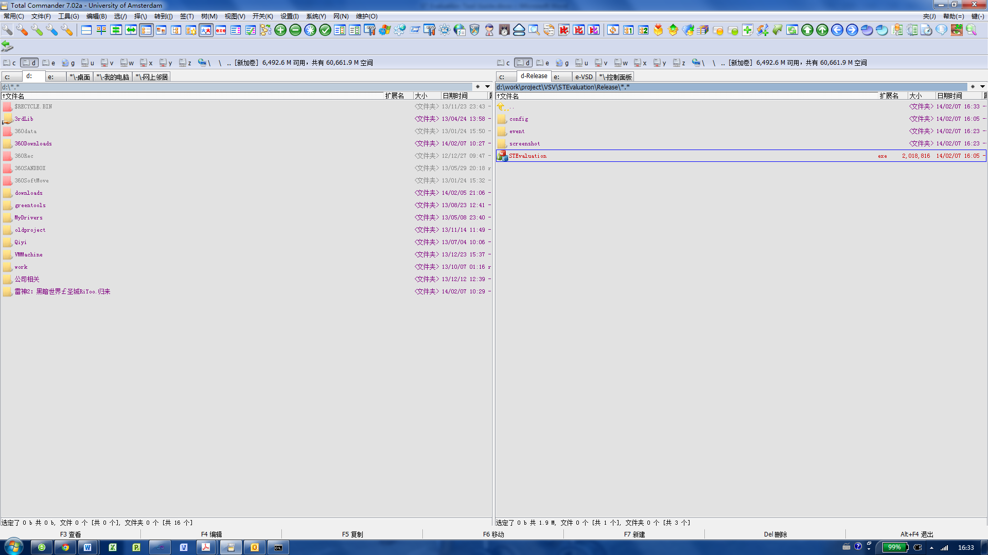

1. Double click ***setup.exe*** to install ST Diagnostic tool, the installed directory structure is shown below:

|  |
| --- |
| STDiagnostic:  │ STDiagnostic.exe (Main program)  ├─Config (Configuration files, don’t change any files in this directory)  │ └─AlgorithmConfig  ├─Event (Event log files (*.csv), don’t remove this directory.  └─Screenshot (Screenshot still pictures (*.JPG), don’t remove this directory. |

The installer will check Microsoft Visual Studio Redistributable Package. If the package has not been installed or hasn’t been installed correctly, installation will guide you through the screen shown below, click **[Install]** button when you see following dialog screen.

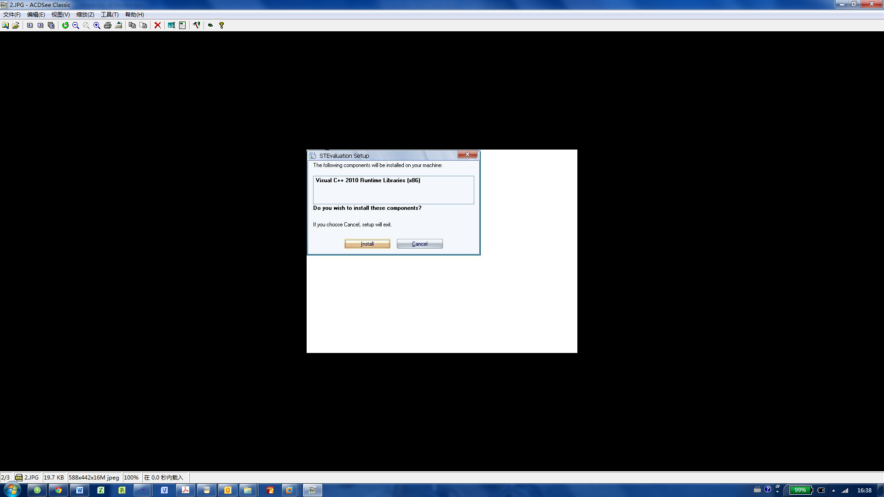

1. Double click ***STDiagnostic.exe*** on your computer desktop (as shown below) to run the SmokeTrace Diagnostic tool.

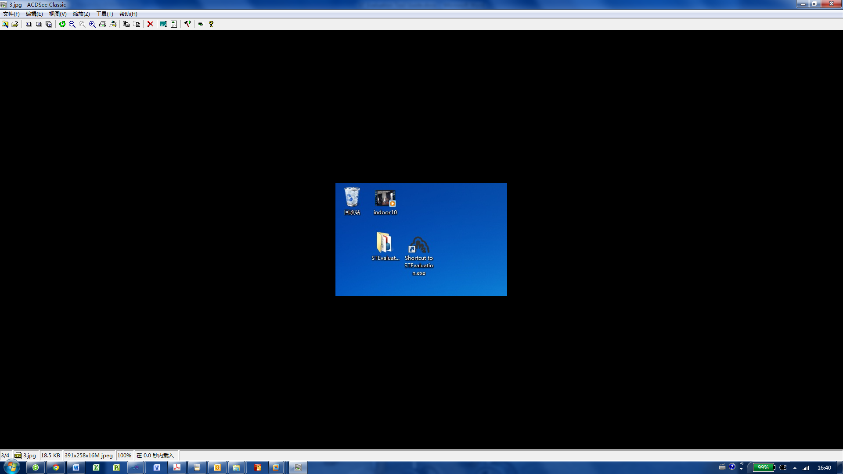

1. **First time long in**

When login first time, use the default password “123456”.

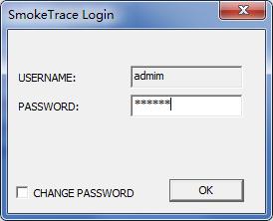

Once the default password is keyed in, tick the checkbox [Change Password] to change your password. Once **[OK]** button is pressed, a second screen as shown below will pop up. Simply type in the old and new passwords then press **[OK]** button. For future use of the tool, the new password will apply.

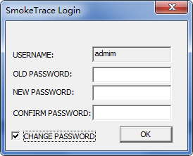

Once a valid password is accepted, the tool main screen will show. SmokeTrace Diagonostic tool main screen consists of the following functions:

1. Heading: display the tool version number and SmokeTrace algorithm revision.
2. Diagnostic Method: Select how the diagnostic operation is executed. This includes selection from a pre-recorded video file, use of a camera for real time processing or review video processing results with tagged events.
3. Display Panel: Area where video or images are displayed.
4. Selection & Control Buttons: Use the buttoms to control the video and image DAT or change of the tool configuration.
5. Event List: List of all events detected.

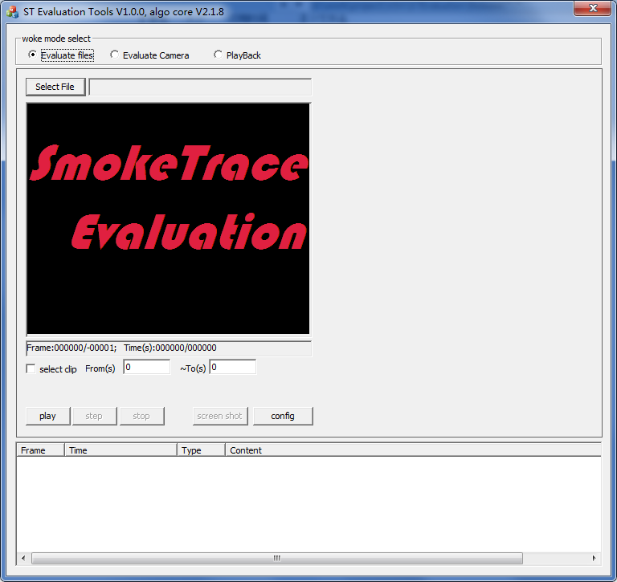

Event List

Selection & Control Buttons

Display Panel

Diagnostic Method

Heading

# Diagnostic Method: Pre-recorded Video Processing

1. SmokeTrace Diagnostic tool uses Windows system codec to decode video files. Make sure the pre-recorded video file is valid and supported by Windows. If a file can be opened with Windows Media Player, it can be loaded to the tool. AVI file is used in the User Guide as example as this is a commonly used file format. .
2. Select “**Pre-recorded Video**” from the Diagnostic Method as shown below.

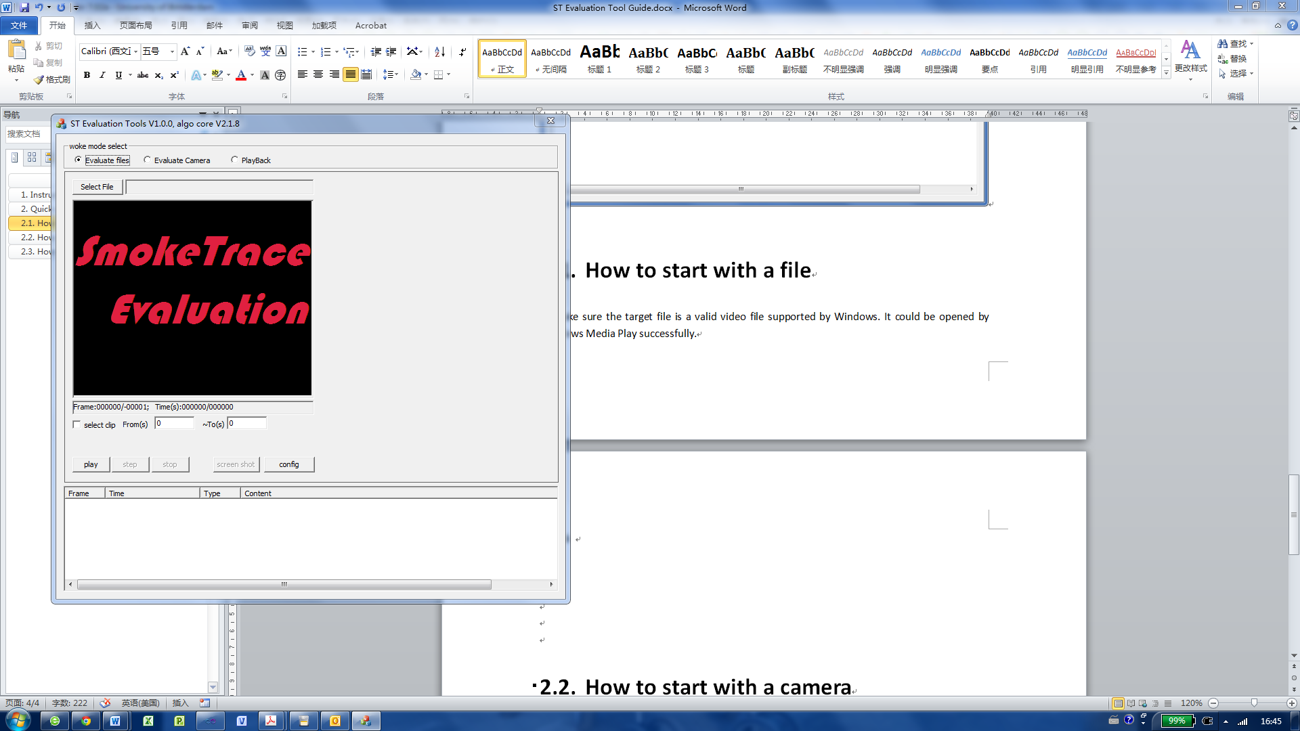

1. Click button **[Open File]** to select a video file (e.g. *.avi) from the folder.

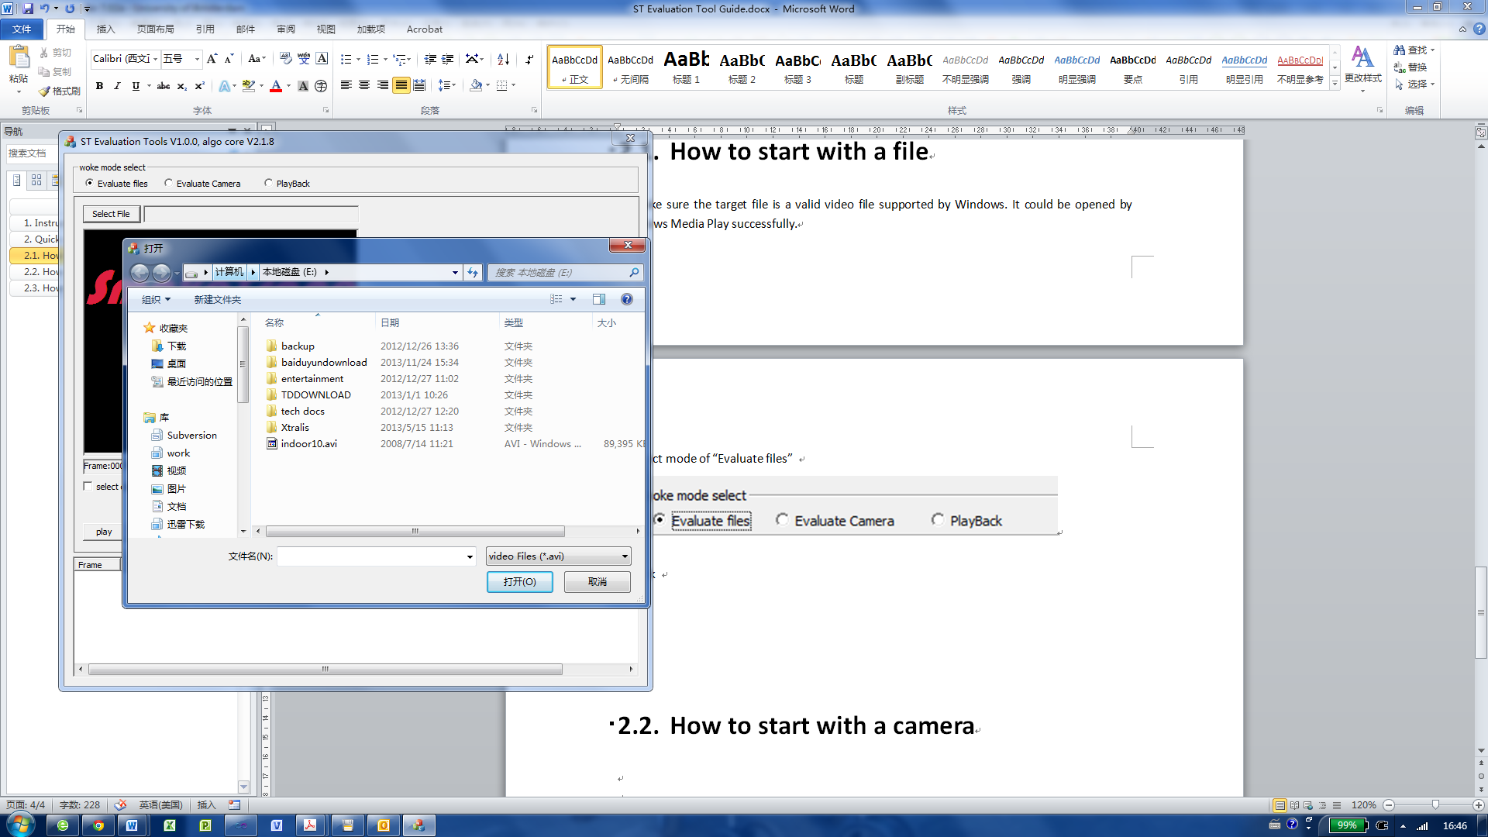

1. If necessary, click button **[Config]** to set the configuration parameters for SmokeTrace algorithm, then press [OK] to confirm.

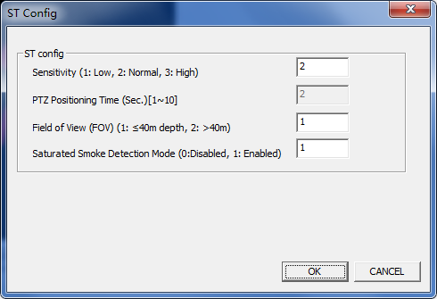

1. Click button **[Play]** to begin processing

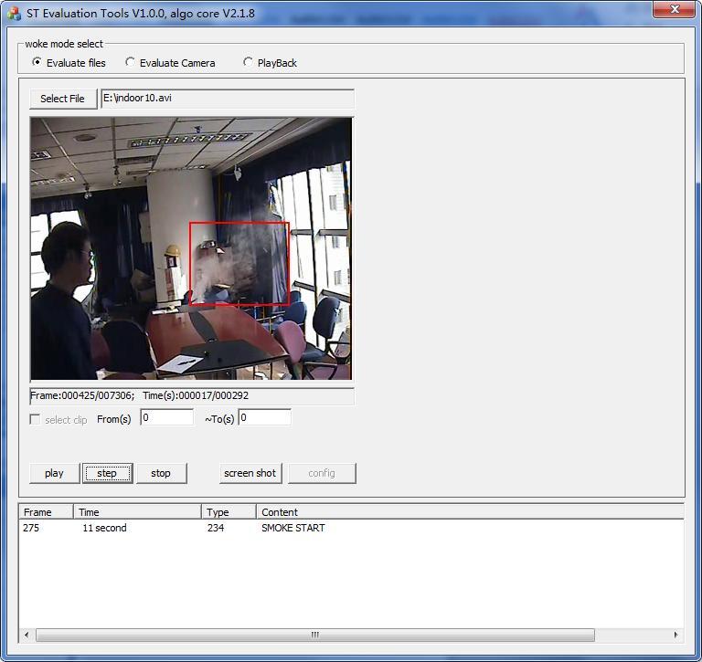

1. During video processing session, the following play modes are available:
2. Press **[Step]** button once while playing the video can pause the video, press **[Step]** again to move to next frame.
3. Press **[Start]** button anytime to resume the normal process mode.
4. Press **[Stop]** button to stop the video processing session.
5. When there are events (e.g. detecting a smoke scene), event is displayed on the “Event List” as it occurs. The entire Event List is saved to a CSV file automatically. The CSV filename is the same as the input video filename with extension of csv, and is saved under the same directory.

An output filename *.dat for review (playback) is also saved at the same time.

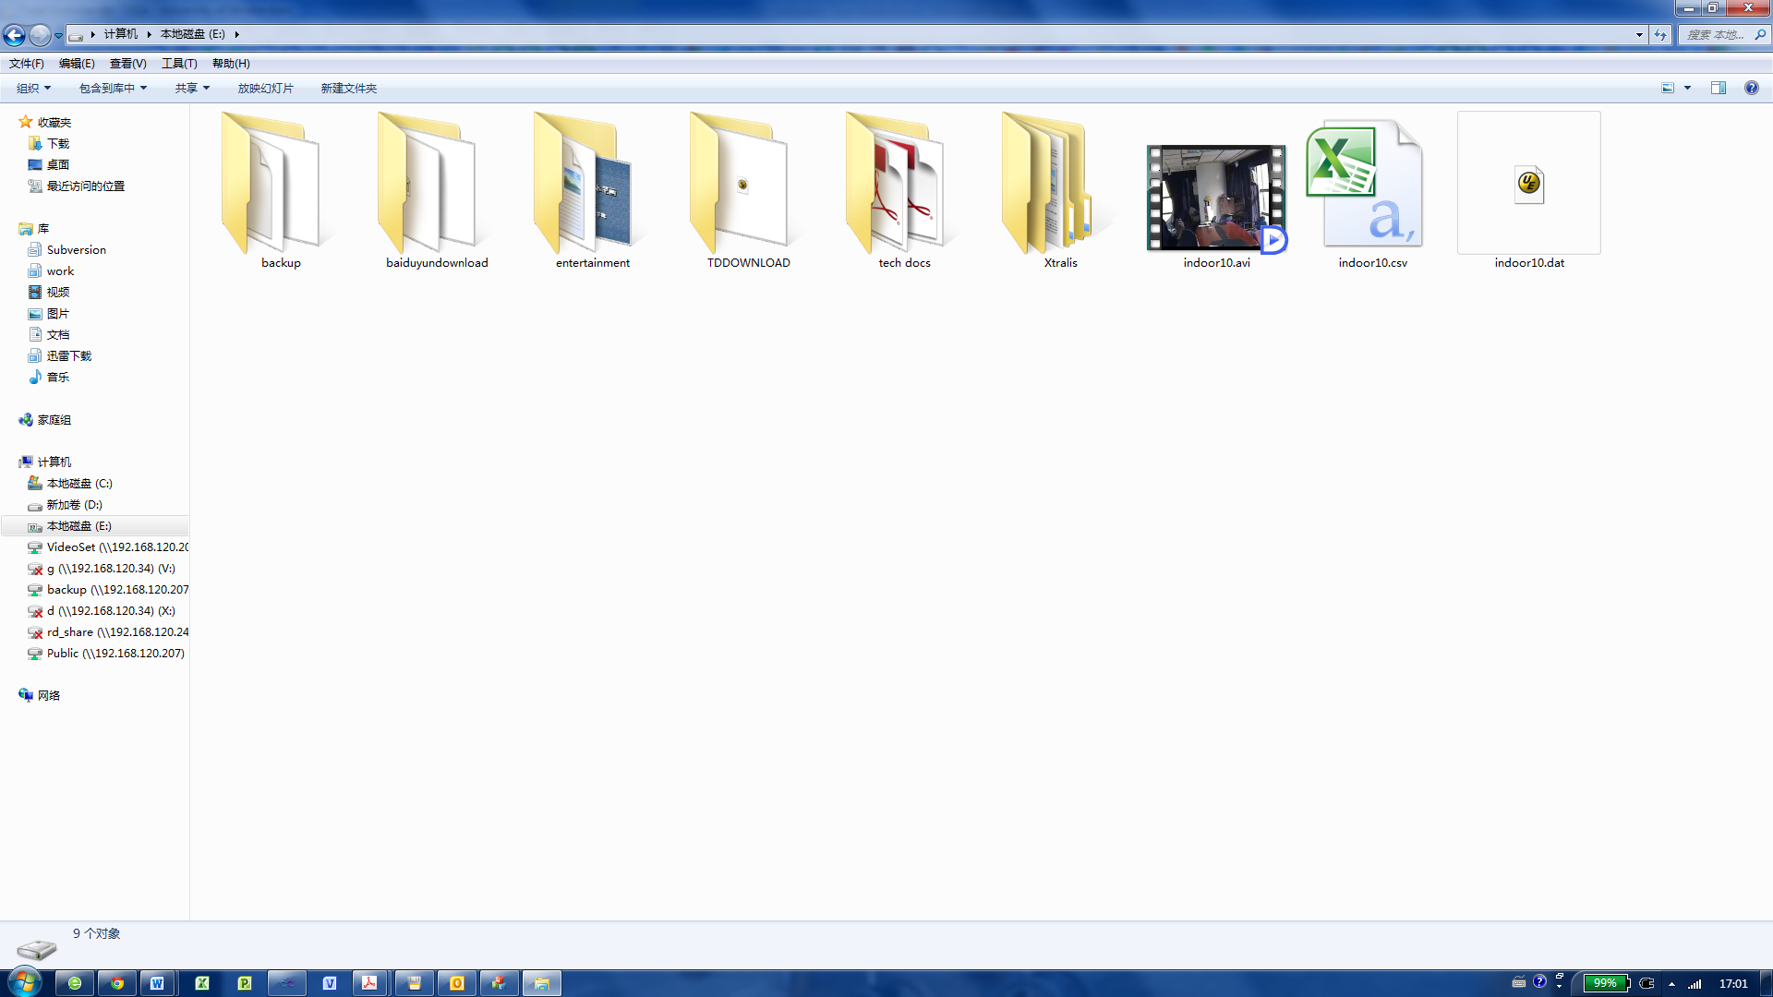

Input video file

Event file

Output file

1. At any time when a still frame needs to be saved, click button **[Still Image]** to create a JPG file of the image on the screen. The JPG file resolution is set at 352x288 pixel. All still images are saved in the directory “/STDiagnostic/Still Images”

# Diagnostic Method: Camera Real Time Processing

1. Select Diagnostic Method “Camera”

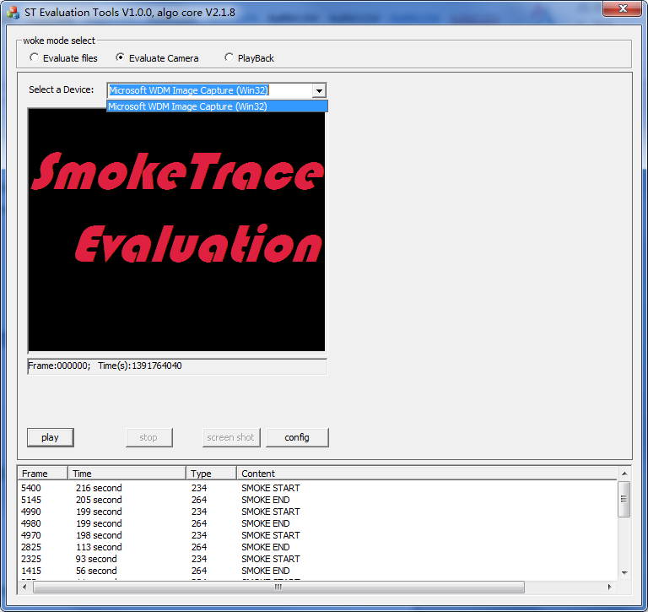

1. Select a supported device on your computer. If a camera is recognized by Windows and registered in the Hardware registry, it will be included in the pull down list.



1. Select the camera then click **[Start]** button. A live video stream will be shown on the screen as following.

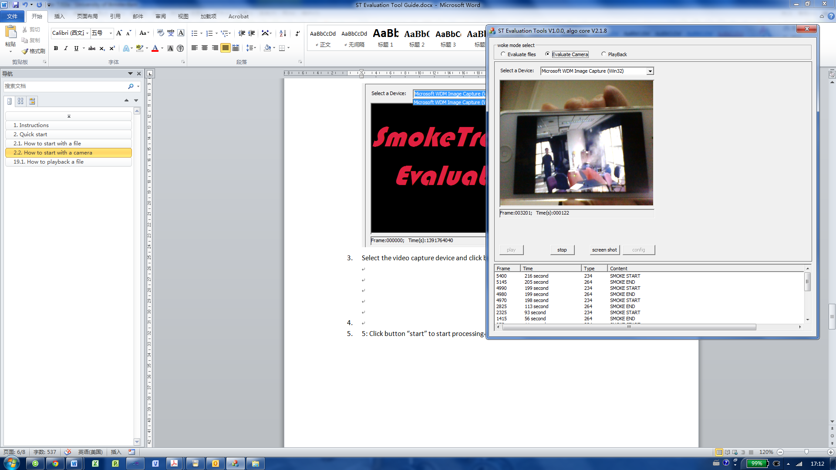

1. When an event occurs, it will be added in the Event List. At the same time, the event is recorded in a CSV file. Each event is time stamped , and the CSV file is saved in the directory ”/STDiagnostic/Event”)

An event will triger a still frame capture automatically and saves 12 pictures with an interval of 12 seconds in the folder “/STDiagnostic/Still Image”. This is so the event can be reviewed later on to see when and how the event develops

# Diagnostic Method: Review Video with Events

After processing a pre-recorded video file such as a AVI file, there are 2 files created in the same folder as for the AVI file. They are DAT and CSV files. The AVI file can then be reviewed (playback) with the processing results saved in these files.

1. Select Diagnostic Method “Review”

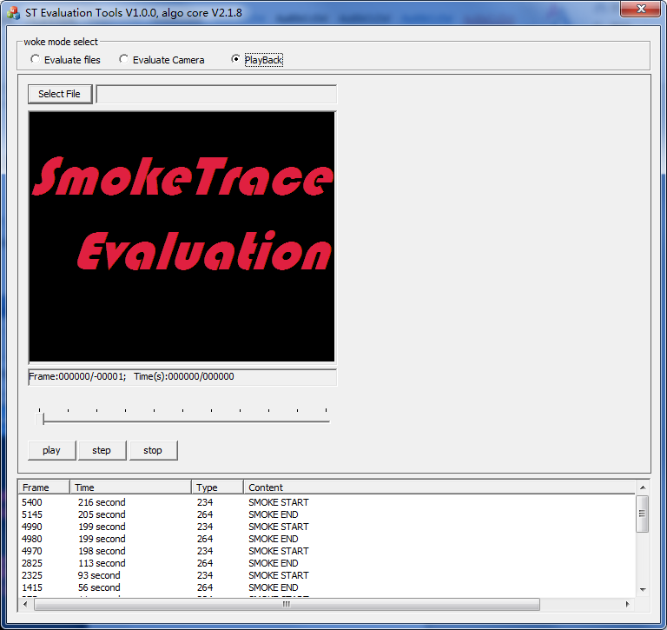

1. Click button **[Open File]** to select an AVI file. Make sure that there are CSV and DAT files stored in the same folder.
2. Click button **[Start]** to begin playback and review. **[Step]** button and its associated functions are also valid in “Review” mode.

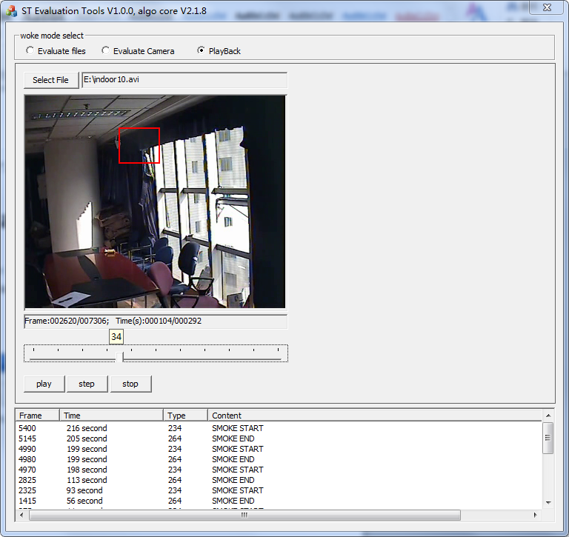

# CSV file Format

Open file in Microsoft Excel.

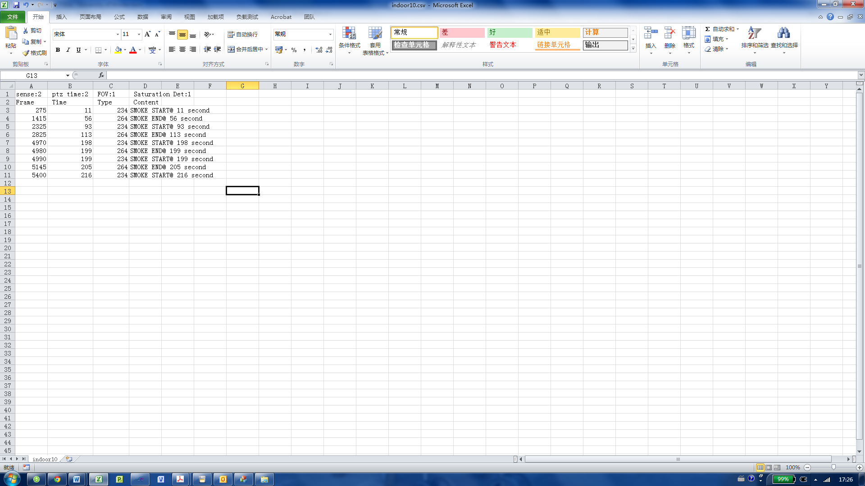

Frame index of the event (in pre-recorded video processing methiod only)

Event description

1st row shows the SmokeTrace configuration parameters used for processing

Time stamp of the event in seconds